





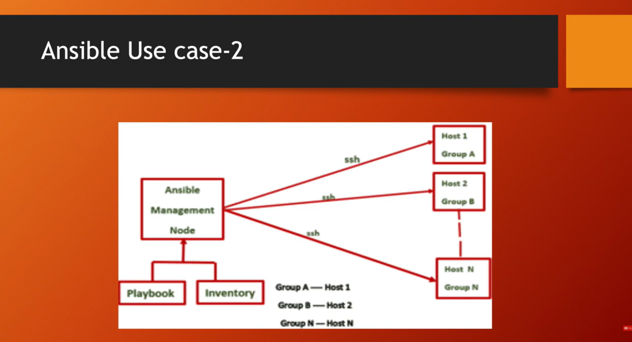



<https://docs.ansible.com/ansible/latest/installation_guide/installation_distros.html>

sudo yum install ansible-core



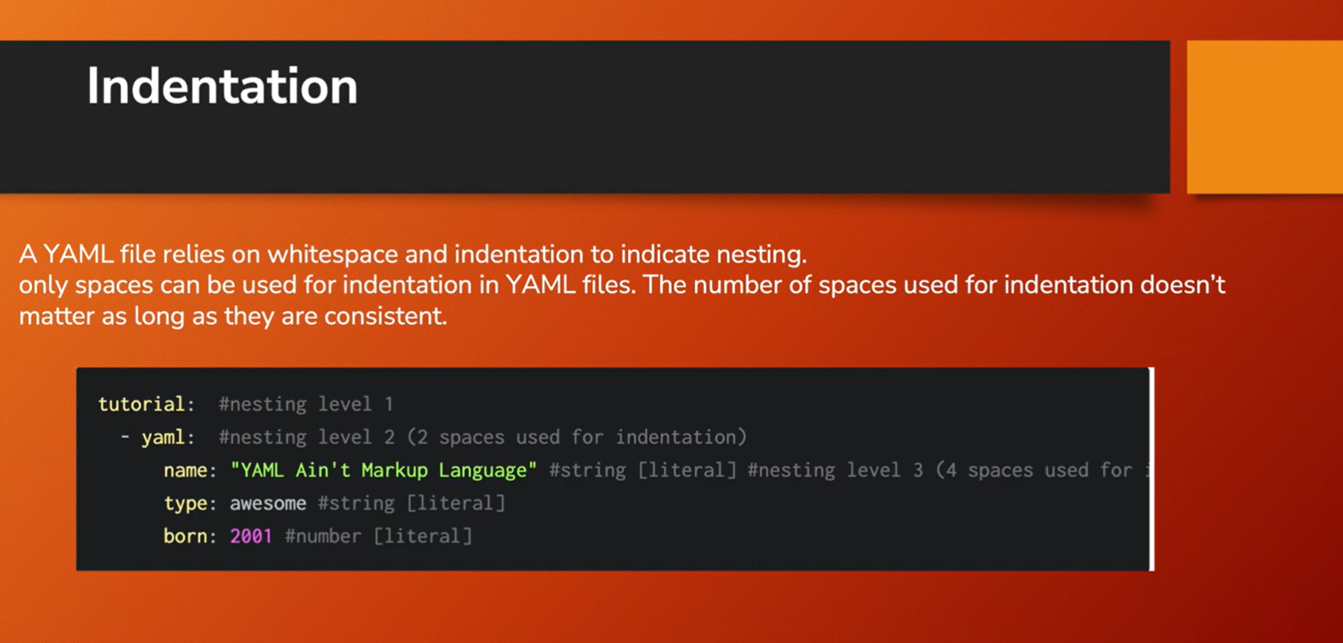







Ansible ping module :s

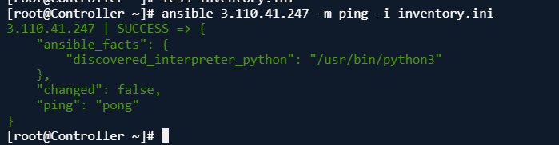

Here’s a curated list of **most useful Ansible ad-hoc commands:**

**🔧 System Management**

| **Task** | **Command** |
| --- | --- |
| **Ping a host** | ansible all -m ping |
| **Check uptime** | ansible all -a "uptime" |
| **Reboot a host** | ansible all -a "reboot" |
| **Check disk usage** | ansible all -a "df -h" |
| **Check memory usage** | ansible all -a "free -m" |

**📁 File & Directory Operations**

| **Task** | **Command** |
| --- | --- |
| **Create a directory** | ansible all -m file -a "path=/tmp/testdir state=directory" |
| **Delete a file** | ansible all -m file -a "path=/tmp/testfile state=absent" |
| **Copy a file** | ansible all -m copy -a "src=/etc/hosts dest=/tmp/hosts" |
| **Change file permissions** | ansible all -m file -a "path=/tmp/testfile mode=0644" |

**📦 Package Management**

| **Task** | **Command** |
| --- | --- |
| **Install a package (e.g., httpd)** | ansible all -m yum -a "name=httpd state=present" |
| **Remove a package** | ansible all -m yum -a "name=httpd state=absent" |
| **Update all packages** | ansible all -m yum -a "name=* state=latest" |

**🔥 Service Management**

| **Task** | **Command** |
| --- | --- |
| **Start a service** | ansible all -m service -a "name=httpd state=started" |
| **Stop a service** | ansible all -m service -a "name=httpd state=stopped" |
| **Restart a service** | ansible all -m service -a "name=httpd state=restarted" |
| **Enable a service at boot** | ansible all -m service -a "name=httpd enabled=yes" |

**👤 User Management**

| **Task** | **Command** |
| --- | --- |
| **Create a user** | ansible all -m user -a "name=testuser state=present" |
| **Delete a user** | ansible all -m user -a "name=testuser state=absent" |
| **Add user to group** | ansible all -m user -a "name=testuser groups=wheel append=yes" |

**📡 Networking**

| **Task** | **Command** |
| --- | --- |
| **Check open ports** | ansible all -a "netstat -tuln" |
| **Get IP address** | ansible all -a "ip a" |
| **Flush DNS cache** | ansible all -a "systemd-resolve --flush-caches" |

s